CN A1
Laiba Fatima 22k-5195
Compile in cmd
gcc -o proxy server.c start_server.c handle_client.c -Wall -lws2_32
Run server on specified port (asking user during runtime)
./proxy
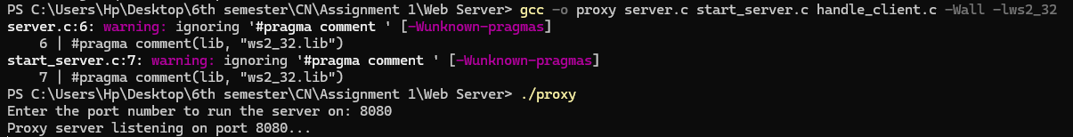
Changed Proxy
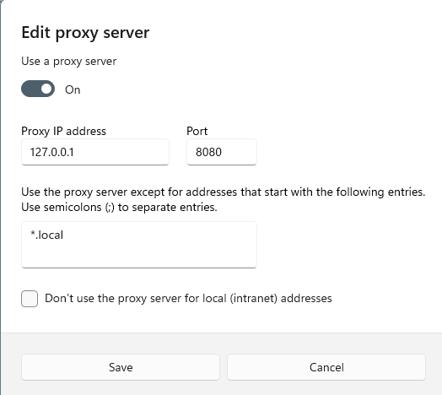
Run command in terminal of vscode
Success GET method
curl.exe -v --proxy 127.0.0.1:8080 http://example.com
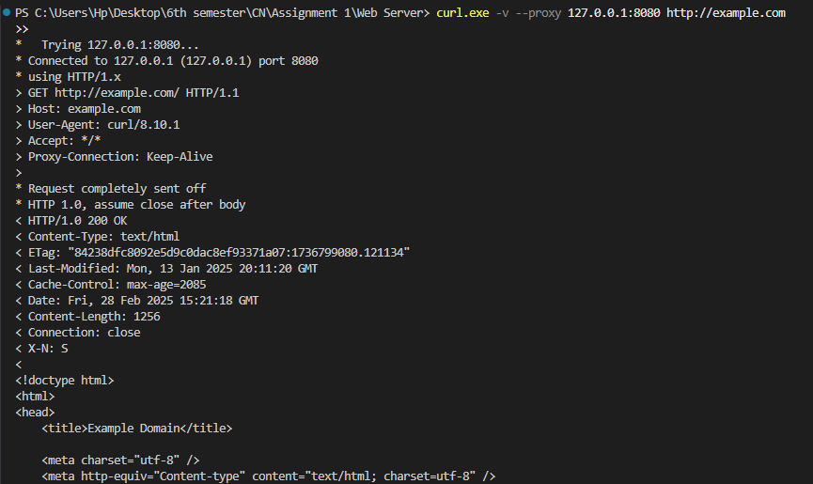
Bad Request
curl.exe -v --proxy 127.0.0.1:8080 -H "Host:" http://example.com
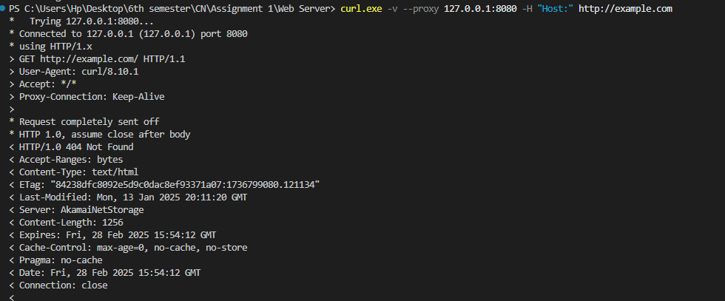
Not Implemented Methods
curl.exe -v --proxy 127.0.0.1:8080 -X POST http://example.com -d "key=value"
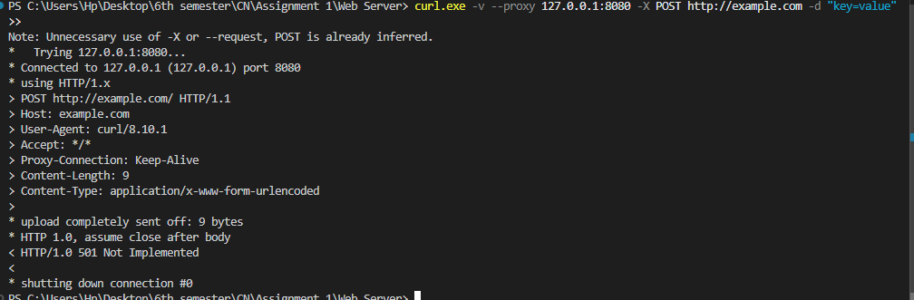
Forbidden
curl.exe -v --proxy 127.0.0.1:8080 http://neverssl.com

